**Devil May Drive**

Contents:

* Project description:
* Our team:
* Project information:

1. Description:
2. Communication:

* Technologies used:

# Project description:

Devil May Drive is a website for a car rental service, built using HTML and CSS. The goal of the site is to present a clean and professional interface where users can view and book available rental cars, learn about rental terms, and find contact information.

# Our team:

|  |  |  |
| --- | --- | --- |
| Names: | Classes: | Roles: |
| Martin Jelev | 8 V | Scrum Trainer |
| Georgi Nikolov | 8 A | Front End Developer |
| Alexander Dyanov | 8 G | Back End Developer |
| Dimitar Nyagalov | 8 B | Designer |

# Project information:

## Description:

Devil May Drive is a car rental website, programmed using HTML and CSS. The goal of the site is to present a clean and professional interface where users can view and book available rental cars and find contact information as potential buyers.

## Communication:

For communication we used Microsoft Teams and talked in person face to face. We also used GitHub for collaborative work. It made it way easier to work.

# Technologies used:

|  |  |
| --- | --- |
| Visual Studio Code | Used for coding and editing text |
| GitHub | Used for committing |
| Canva | Used for design |
| Microsoft Teams | Use for communicating |
| Microsoft Word | Used for creating the documentation |
| Microsoft PowerPoint | Used for creating the presentation |
| ChatGPT | Used for creating the logo |

# Ways of realisation:

Assignment of tasks

Solution: We separated the tasks based on our skills and assigned them where they could be more productive.

Task Completion

Solution: We talked almost every day in the Teams chat to talk about our tasks. We worked at our own convenient time. We also set branches in VSC to be easier for us to know what we must do.

Deadlines

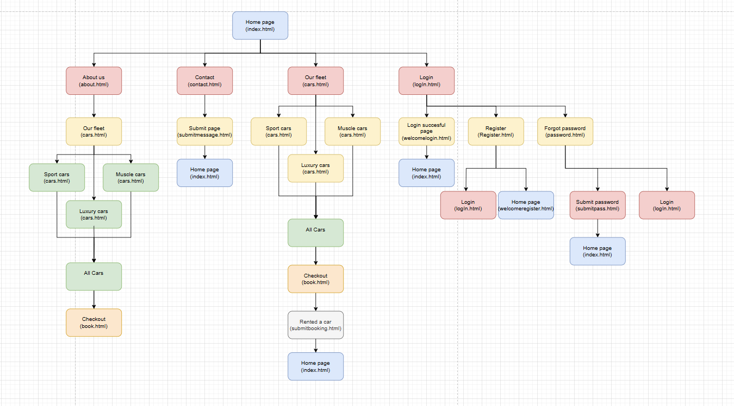Solution: The Scrum Trainer set deadlines for each task given and made sure to consider each task’s difficulty.